**Dovydas Kasiliauskis, PS – 0/2 grupė, 10 variantas**

**1 užduotis**

**23.**

ats=((sqrt(2)+2)^2-(sqrt(2)-2)^2)/(1+(1/12)^(-5/2))

%ats = 0.022635

**2 užduotis**

**7.**

A=[2 5;6 9;4 5;2 9;3 5;1 8]

%A =

2 5

6 9

4 5

2 9

3 5

1 8

B=[1 5 3 6;2 4 8 6;3 5 8 2;2 6 9 2;5 7 9 3;2

4 8 3]

%B =

1 5 3 6

2 4 8 6

3 5 8 2

2 6 9 2

5 7 9 3

2 4 8 3

C=[2;2.5;3;3.5;4;5]

%C =

2.0000

2.5000

3.0000

3.5000

4.0000

5.0000

AB=[A,B]

%AB =

2 5 1 5 3 6

6 9 2 4 8 6

4 5 3 5 8 2

2 9 2 6 9 2

3 5 5 7 9 3

1 8 2 4 8 3

AB1=[A B]+1

%AB1 =

3 6 2 6 4 7

7 10 3 5 9 7

5 6 4 6 9 3

3 10 3 7 10 3

4 6 6 8 10 4

2 9 3 5 9 4

D=AB1

%D =

3 6 2 6 4 7

7 10 3 5 9 7

5 6 4 6 9 3

3 10 3 7 10 3

4 6 6 8 10 4

2 9 3 5 9 4

D(1,:)=[]

%D =

7 10 3 5 9 7

5 6 4 6 9 3

3 10 3 7 10 3

4 6 6 8 10 4

2 9 3 5 9 4

D(3,:)=[]

%D =

7 10 3 5 9 7

5 6 4 6 9 3

4 6 6 8 10 4

2 9 3 5 9 4

CD=D*C

CD =

136.50

109.00

129.00

109.00

**3 užduotis**

**1.**

syms x y z

lygtis1 = 2*x + y == 5

%lygtis1 = (sym) 2*x + y = 5

lygtis2 = x + 3*z == 16

%lygtis2 = (sym) x + 3*z = 16

lygtis3 = 5*y - z == 10

%lygtis3 = (sym) 5*y - z = 10

[solx,soly,solz]=solve([lygtis1 lygtis2 lygtis3],[x

y z])

%solx = (sym) 1

%soly = (sym) 3

%solz = (sym) 5

**6 užduotis**

**8.**

A = [1 0 -2]

%A =

1 0 -2

saknys = roots(A)

%saknys =

-1.4142

1.4142

x = -1.4:0.1:1.4;

y = x.^5 - 2;

plot(x,y)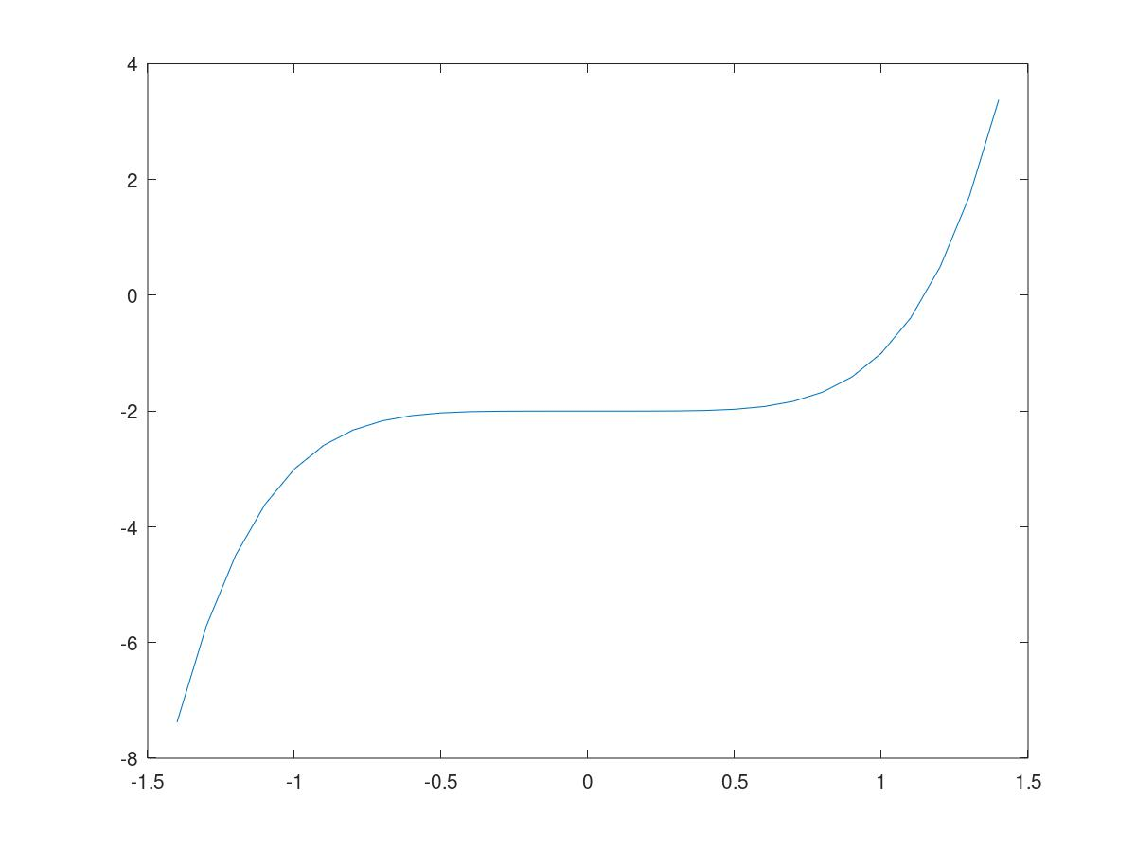

**7 užduotis**

**20.**

a = 5

%a = 5

perimetras = 5/20*100

%perimetras = 25

b = a

%b = 5

c = (25-10)/2

%c = 7.5000